Originator:
Name | Job Title | Signature | Date
Andrew Mason | Chief Technology Officer
Approvals:
Name | Job Title | Signature | Date
Nancy Rizzo | Founder and CEO
Scott Pletzer | Director of Quality and Program Management

Purpose

The purpose of this document is to describe the specifications and design that will be implemented for the Analysis Functions in the ClearView system.

- General Requirements

Where appropriate, logic should be contained in try/catch blocks and any exceptions should be logged using the standard logging mechanisms.

- Specifications

Requirement #4.1: Image analysis must take place immediately upon request by the user after all of the images are captured.

Specification: Once all of the images have been captured and before anything is committed to the database the 'Submit for Analysis' button will become enabled. When the user presses this button, the system will prevent any other buttons from being pressed and will begin the analysis process.
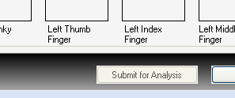
Once the images have been collected, the user only has two choices, either cancel the process as a whole, or run the analysis.

Requirement #4.2: Analysis requires a set of 10 filtered and 10 unfiltered images.

Specification: Before the analysis process can begin a collection of twenty images must be captured. Ten of the images are to be collected without a capacitive barrier and ten with a capacitive barrier. The user cannot continue the process until all twenty images have been captured.

Requirement #4.3: A valid calibration set must be current and available before analysis can begin.

Specification: In order to access the capture process, a check is done by the system before displaying the capture dialog to verify that a calibration is stored and available. The rules as to what a valid calibration consists of are defined in the Camera Functions- Specifications. If no calibration is available, the user is not allowed to go to the capture screen and a message is displayed letting them know that a calibration must be run.

Requirement #4.4: The general data flow will be as follows:
Collect images → Perform coefficients calculations → Store raw data (coefficient calculations) → Run raw data through analysis algorithm → Result in Response Scale Measurement (GSR measurements), NB score and LR score→ store analyzed data → produce a report.

Specification: The system has been programmed to the following flow, each of these areas are defined in subsequent documents:

- Select a patient.
- Collect the images (Capture Specifications).
- Generate coefficients from the images (Analysis Specifications).
- Save the images and raw data to the database.
- Perform the analysis of the coefficients (Analysis Specifications).
- Produce the report output.

Requirement #4.5: The system must calculate a noise value which will be referred to as the background noise level. This level should be the pixel intensity below which will be considered 0 or no intensity at all. This process is documented in the Algorithm Requirements.

Specification: The background noise is defined as the intensity that is captured in the image in areas that are known to be void of data. An example of this would be the center of a calibration image, or the center of an energized finger image. The background noise level is calculated by determining at what intensity level only .02% of the pixels in the middle of the image are lit. The center of the image is used because in theory this should be an area completely void of light and therefore representative of what the background of the image should look like.
The routine will iterate through the following loop until the result of the final calculation is < .02% of the total area in question.
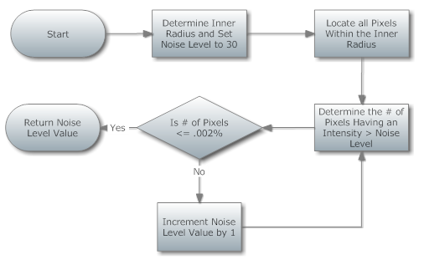
When the comparison returns true, we have arrived at the Background noise value, in most cases this value is between 30 and 45.

Requirement #4.6: Energized finger images are to be divided for analysis into sectors; these sectors are to be unique for each finger and will be known as finger sectors. All calculations will be done based on the area within the specified sector.

Specification: The size of each finger sector is defined in the ClearView Finger Sector Map which specified the beginning sector angle and the ending sector angle labeled by the finger name and the ultimate organ system label used to store the results. This process is documented in the Algorithm Requirements.

Requirement #4.7: The number of pixels within a sector that are above the noise level should be measured, this coefficient will be known as the sector area.

Specification: The area is the number of pixels that have intensity greater than a specified noise level within a given sector. The pixels contained in the sector are determined by selecting all pixels inside the ellipse that are contained within a certain angle segment corresponding to this sector. The value returned for this calculation is between 0 and the number of pixels in the largest defined sector.

Requirement #4.8: The area respective to the size of the sector must be calculated, this coefficient will be known as the normalized area.

Specification: This is the area value determined above, that is then normalized for the size of the sector that it represents. The normalization process is given by the formula:
Area Value * ((360 / #of Sectors)/ Angle of the sector)

Requirement #4.9: The average intensity of all pixels in a sector must be determined; this coefficient will be known as average intensity.

Specification: The Average Intensity per sector is computed by dividing the sum of intensities of all pixels in the sector area by the number of pixels in the sector area.

Requirement #4.10: The measurement of disorganization in a sector should be measured; this coefficient will be known as the entropy.

Specification: The Entropy of each sector is computed by first computing the standard Shannon Entropy along each profile. The profiles are created through the following process:
The image is traversed radially in a clockwise manner with the center point of the ellipse serving as midpoint. This is done in steps of 1/4 of an angular degree. For each of the resulting 360x4 = 1440 angles, an image profile is computed by choosing the pixels from the active area that intersect with a ray at one of the 1440 angles and centered at the ellipse midpoint.
The final value is determined by calculating the entropy of each profile within a sector and then averaging the result across all profiles within the sector.

Requirement #4.11: Measure the level of continuity along the radii of the sectors, this coefficient will be known as form. The form coefficient will encompass approximately 2/3 of the depth of the sector.

Specification: After having determined the active area of the finger image as described above, the image is traversed radially in a clockwise manner with the center point of the ellipse serving as midpoint. This is done in steps of 1/4 of an angular degree. For each of the resulting 360x4 = 1440 angles, an image profile is computed by choosing the pixels from the active area that intersect with a ray at one of the 1440 angles and centered at the ellipse midpoint. Furthermore, the active image area is divided into three concentric rings. The form value for each sector consists of three coefficients, one for each of the three rings. Each such coefficient is a weighted sum of three different coefficients C1,C2, and C3.
The coefficient C1, the derivative coefficient, measures the amount of change in pixel intensity along each profile within a given ring. Amount of change is quantified by computing the derivative of the aforementioned profile.
The coefficient C2 measures whether there is a gap in the inner finger image contour and assigns a value corresponding to the size of such a gap.
The coefficient C3 measures whether there is an abrupt break (sudden drop in pixel intensity) along the profiles. For robustness against noise, several profiles are analyzed simultaneously for the presence of a break.

The form coefficient will encompass approximately 2/3 of the depth of the sector, a separate coefficient called Form2 will look at the outer 1/3 of the sector.

Requirement #4.12: Breaks or lines in a sector will be known as Break Coefficient.

Specification: The break coefficient for each sector is computed by measuring whether there is an abrupt break (sudden drop in pixel intensity) along the profiles.
For robustness against noise, several profiles are analyzed simultaneously for the presence of a break.

Requirement #4.13: A measurement of the fractal dimension in a sector must be calculated, this coefficient will be known as fractal.

Specification: The Fractal Dimension of the active area in a sector is computed by computing the fractal dimension (in its mathematical sense) using the standard box-counting method for a two-dimensional area.

Requirement #4.14: A measurement of the difference between a calibration image and the captured energized image per sector must be reported, this coefficient will be known as NS.

Specification: The NS coefficient is computed via the formula:

Average Intensity(Image sector) / Aver. Int.(Calibration sector) -------------------------------------------------------------------------------------------------------- - 0.5
L_Image / L_Calibration

Where:
L_Image = Log (Number of active pixels/Number of total pixels + epsilon) per each sector of the finger image.
L_Calibration = Log (Number of active pixels/Number of total pixels + epsilon) per each sector of the calibration image;
Here, the value epsilon = 10^(-4) is added for stability reasons to avoid that the values of L_image and L_Calibration become too small (which would happen in the rare case of numerator and denominator being almost identical).The value 0.5 in the above formula is subtracted for normalization purposes.
When these coefficients have been calculated for each sector on each finger, the results are persisted into systems database for use in the next section.

Requirement #4.15: A measurement of form in the first quadrant of the sector must be reported, this coefficient will be known as Form1_1.

Specification: This coefficient is calculated in the same manner as described in 4.11, but using only the first ¼ of the total sector (measured from the inner ring) as the measurement area.

Requirement #4.16: A measurement of form in the first quadrant of the sector must be reported, this coefficient will be known as Form1_2.

Specification: This coefficient is calculated in the same manner as described in 4.11, but using only the second ¼ of the total sector (measured from the inner ring) as the measurement area.

Requirement #4.17: A measurement of form in the first quadrant of the sector must be reported, this coefficient will be known as Form1_3.

Specification: This coefficient is calculated in the same manner as described in 4.11, but using only the third ¼ of the total sector (measured from the inner ring) as the measurement area.

Requirement #4.18: A measurement of form in the first quadrant of the sector must be reported, this coefficient will be known as Form1_4.

Specification: This coefficient is calculated in the same manner as described in 4.11, but using only the fourth ¼ of the total sector (measured from the inner ring) as the measurement area.

Requirement #4.19: A measurement of the average intensity in the first quadrant of the sector must be reported, this coefficient will be known as AI1.

Specification: This coefficient is calculated in the same manner as described in 4.9, but using only the first ¼ of the total sector (measured from the inner ring) as the measurement area.

Requirement #4.20: A measurement of the average intensity in the first quadrant of the sector must be reported, this coefficient will be known as AI2.

Specification: This coefficient is calculated in the same manner as described in 4.9, but using only the second ¼ of the total sector (measured from the inner ring) as the measurement area.

Requirement #4.21: A measurement of the average intensity in the first quadrant of the sector must be reported, this coefficient will be known as AI3.

Specification: This coefficient is calculated in the same manner as described in 4.9, but using only the third ¼ of the total sector (measured from the inner ring) as the measurement area.

Requirement #4.22: A measurement of the average intensity in the first quadrant of the sector must be reported, this coefficient will be known as AI4.

Specification: This coefficient is calculated in the same manner as described in 4.9, but using only the fourth ¼ of the total sector (measured from the inner ring) as the measurement area.

Requirement #4.23: A measurement of the number of pixels along radii that are within a specific intensity of each other must be calculated. In some cases this value may be zero. This coefficient will be known as Ring Thickness.

Specification: This coefficient is calculated by determining the average ring thickness that appears at the base of the image. Not all images will have a ring, in that case the thickness is zero.

Requirement #4.24: A measurement of the number of the average intensity in the area that makes up the value for Ring Thickness must be reported, this will be known as Ring Intensity.

Specification: This coefficient is calculated by determining the average intensity of the pixels that comprise the detected ring for the given sector.

Requirement #4.25: The raw coefficients should be persisted in their original state in a table in the ClearView database.

Specification: The data is stored in a table called AnalysisResults. The table is uniquely keyed by an id, and is referenced back to the treatment by a PatientTreatmentId value.

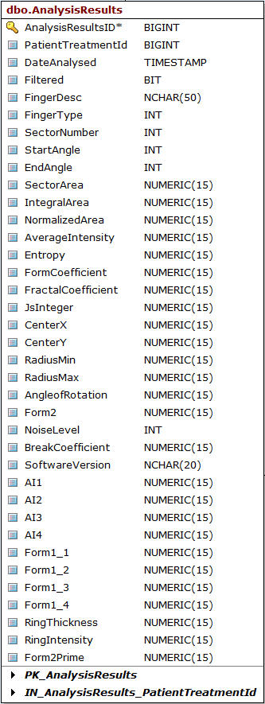

Requirement #4.26: Z Scores will be calculated for each instance of all coefficients as described in SR-203-01.

Specification: The algorithm will perform the following processing on each of the listed coefficient data sets [Area, Average Intensity. . .]
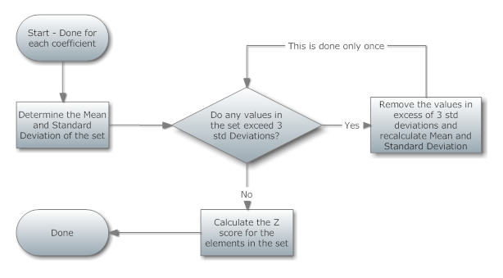
Once the Z scores are created, they are temporarily persisted in memory as the analysis process moves to the next phase. The Z score is calculated using the standard formula:
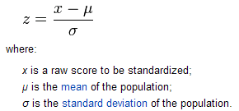

After the calculation of the Z scores, a check is done to determine if any values vall outside of 3 standard deviations. If this condition is realized, a new standard deviation is calculated after removing the outliers from the equation. The resultant Z score is used for the subsequent calculations.

Complete calculation detail can be found in SR-203-01

Requirement #4.27: A base score will be calculated for each finger sector, this score is a product of the weighting factor (which is unique to each coefficient), the calculated coefficient and the coefficient z-score as described in SR-203-01.

Specification: Once the Z scores have been established, for all coefficients and all of their instances, they can then be further developed into a base score. The specifics of the weighting values and mathematical transformations can be found in the document SR-203-01.
Requirement #4.28: Specific combinations of high scoring coefficients will be worth more than others. Rules will be put in place to enforce this. The rules are identified in the Algorithm Requirements.

Specification: Once a base score has been established, a significance factor is then calculated. This is an additional value that would be added to the base score. The significance score is used to flag specific combinations of coefficient values that may represent a higher risk of issue.

The specifics of the mathematical transformations can be found in the document SR-203-01.

Requirement #4.29: A scale will then be applied to the score that was created; the scale will reduce the results to a number between 0 and 25. The EPIC score scaling mechanism is documented in the Algorithm Requirements.

Specification: Once the EPIC raw score has been calculated (Base score + significance factor), the value is compared to a scale to determine the ranking (value of 0-25) that will apply to the score. The scale can be found in the document SR-203-01.

Requirement #4.30: A new scoring process (Naive Bayse) will be added to the scoring calculation. This will be calculated completely independent of the EPIC scoring process.

Specification: The Naïve Bayse scoring has been implemented into the analysis process and the results are manifested on the first page of the ClearView report.

A new set of database tables will be added to the application in order to accommodate the new LR scoring. The tables are show below:
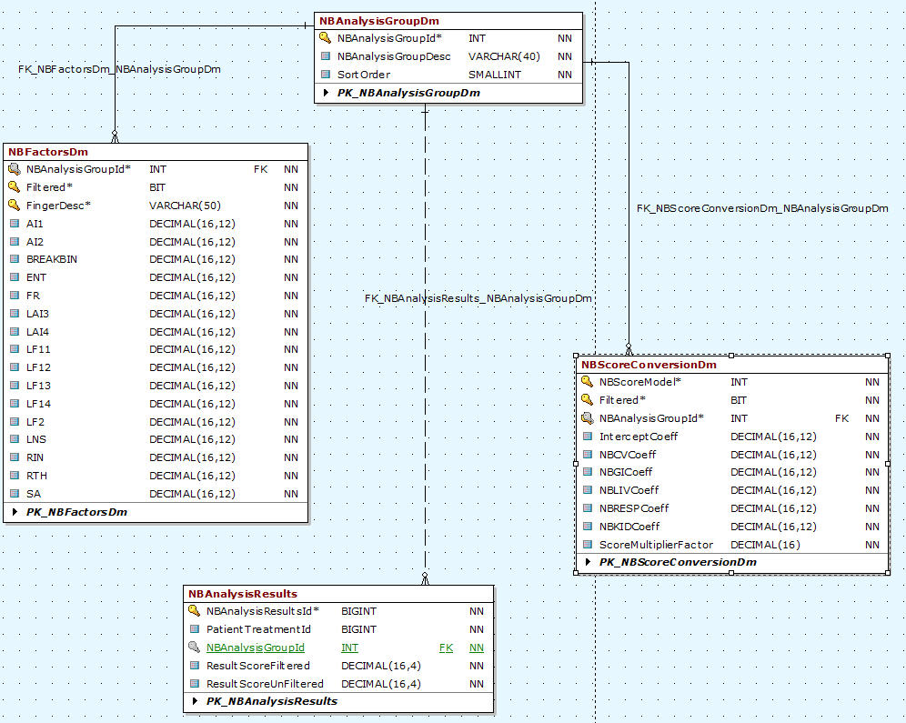

The calculation was implemented as described in SR-203-01.

Requirement #4.31: The Naive Bayse (NB) score will be displayed in a new section in the ClearView report separated from the standard scoring section. This will be treated as an overall score.

Specification: The results of the Naïve Bayse score are displayed on the ClearView report in the first section of the report on the first page of the report.

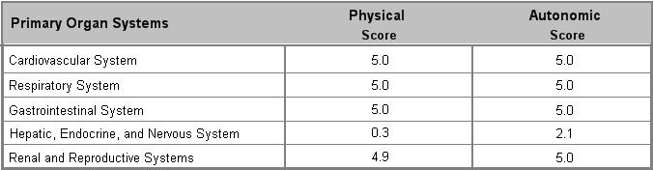

Requirement #4.32: The Logistic Regression score will be calculated. The method of converting the EPIC score value to the final score for the report will be modified to use the process outlined in SR-301-01 to take population data into consideration.

Specification: The LR score as defined in SR-203-01, has been implemented. The factors used for the calculation are stored in database tables and not in the code itself. The code resides in class EPIC.Analysis.SeverityRater.cs.

A new set of database tables will be added to the application in order to accommodate the new LR scoring. The tables are show below:
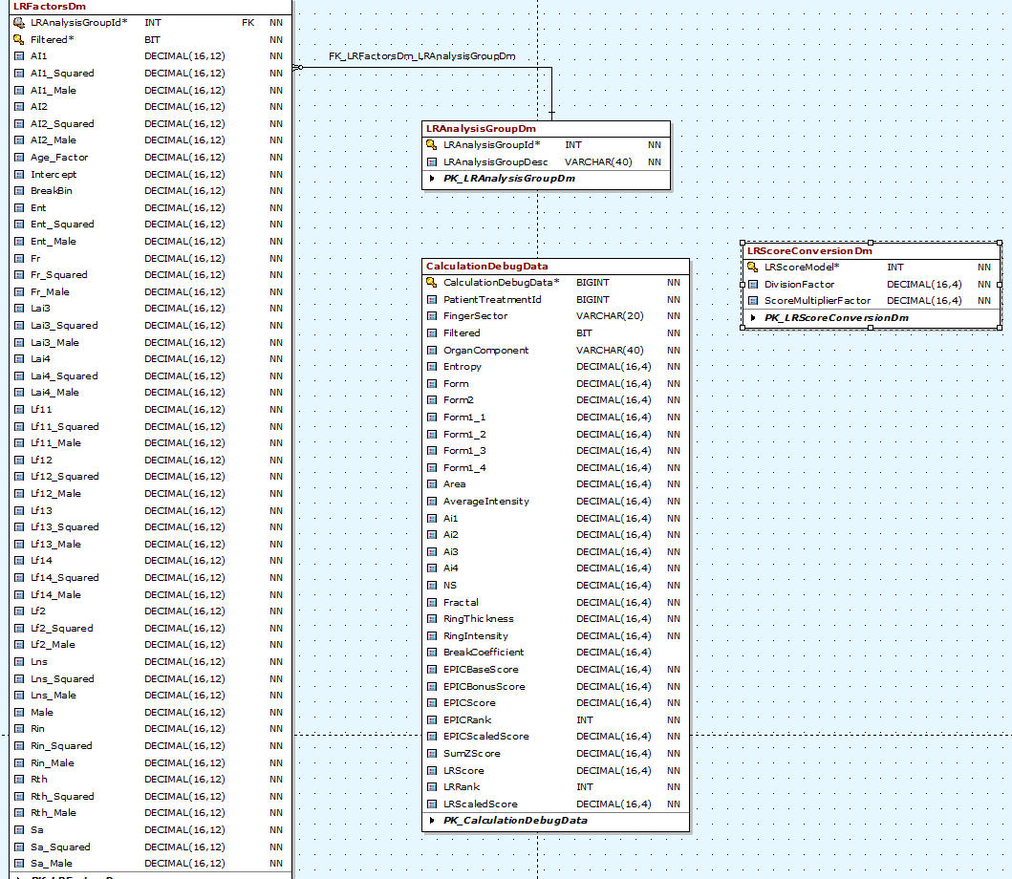

A section of the calculation code is referenced below, this code is repeated for each factor.

// Get the rankings for this entry
mFullRating.TryGetValue(epicResults.Organ[0], out ratingVar);
int BreakVar = ratingVar.BreakCoefficient.Value > 0 ? 1 : 0;
// Configure initial filter (CV)
IPredicate LocalFilter = (LrfactorsDmFields.LranalysisGroupId == GlobalSettings.Reporting.AnalysisGroupings.CARDIOVASCULAR_GROUP);
// Get Cardio factor
indexes = lrfactorsDmCollection.FindMatches(LocalFilter);
lrfactorsDmEntity = lrfactorsDmCollection[indexes[0]];

AgeFactor = (SubjectAge * lrfactorsDmEntity.Age);
AiFactor = (Convert.ToDecimal(ratingVar.AverageIntensity.Value) * lrfactorsDmEntity.Ai);
Ai_NaFactor = ((Convert.ToDecimal(ratingVar.AverageIntensity.Value) * Convert.ToDecimal(ratingVar.NormalizedArea.Value))* lrfactorsDmEntity.AiNa);
BreakBinFactor = (Convert.ToDecimal(BreakVar * lrfactorsDmEntity.BreakBin));
EntropyFactor = (Convert.ToDecimal(ratingVar.Entropy.Value) * lrfactorsDmEntity.Ent);
Entropy_Lf2Factor = ((Convert.ToDecimal(ratingVar.Entropy.Value) * Convert.ToDecimal(Math.Log(ratingVar.Form2.Value))) * lrfactorsDmEntity.EntLf2);
Entropy_LformFactor = ((Convert.ToDecimal(ratingVar.Entropy.Value) * Convert.ToDecimal(Math.Log(ratingVar.FormCoefficient.Value))) * lrfactorsDmEntity.EntLform);
FractalFactor = (Convert.ToDecimal(ratingVar.FractalCoefficient.Value) * lrfactorsDmEntity.Fr);
InterceptFactor = (lrfactorsDmEntity.Intercept);
Lf2Factor = (Convert.ToDecimal(Math.Log(ratingVar.Form2.Value)) * lrfactorsDmEntity.Lf2);
LformFactor = (Convert.ToDecimal(Math.Log(ratingVar.FormCoefficient.Value)) * lrfactorsDmEntity.Lform);
if (!IsFiltered)
Lform_Lf2Factor = ((Convert.ToDecimal(Math.Log(ratingVar.FormCoefficient.Value)) * Convert.ToDecimal(Math.Log(ratingVar.Form2.Value))) * lrfactorsDmEntity.LformLf2);
else
Lform_Lf2Factor = 0;
LnsFactor = (Convert.ToDecimal(Math.Log(ratingVar.JsInteger.Value + 5.0)) * lrfactorsDmEntity.Lns);
MaleFactor = (MaleVar * lrfactorsDmEntity.Male);
NaFactor = (Convert.ToDecimal(ratingVar.NormalizedArea.Value) * lrfactorsDmEntity.Na);
RinFactor = (Convert.ToDecimal(ratingVar.RingIntensity.Value) * lrfactorsDmEntity.Rin);
RthFactor = (Convert.ToDecimal(ratingVar.RingThickness.Value) * lrfactorsDmEntity.Rth);

TotalScoreValue = AgeFactor + AiFactor + Ai_NaFactor + BreakBinFactor + EntropyFactor + Entropy_Lf2Factor + Entropy_LformFactor +
FractalFactor + InterceptFactor + Lf2Factor + LformFactor + Lform_Lf2Factor + LnsFactor +
MaleFactor + NaFactor + RinFactor + RthFactor;
TransformedTotalScore = Convert.ToDecimal(Math.Exp(Convert.ToDouble(TotalScoreValue)) / (1 + Math.Exp(Convert.ToDouble(TotalScoreValue))));

Requirement #4.33: The method of converting the Logistic Regression score value to the final score for the report based on the process outlined in SR-203-01.

Specification: The conversion as defined in SR-203-01 has been completed.

private static Int32 DetermineLRSeverityIndex(Decimal ScoreValue, LrscoreConversionDmEntity Coefficients)
{
Decimal TempScore = Math.Round((ScoreValue / Coefficients.DivisionFactor) * Coefficients.ScoreMultiplierFactor, 0);
// Sanity checks
if (TempScore < 0)
TempScore = 0;
else if (TempScore > 25)
TempScore = 25;
return Convert.ToInt32(TempScore);
}

Requirement #4.34: A process for selecting which of the two scores for each measurement to select (EPIC or Logistic Regression) will be implemented into the score development algorithm.

Specification: The conversion as defined in SR-203-01 has been completed.

private void PickReportScore()
{
// Rule: If EPIC score is higher, always pick EPIC
// If LR score is higher then follow these rules:
// determine the average between the two scores
// If the delta between the two scores is >= 10 then add 4 to the average and use it as the score
// else use the average as the score
// If the value is not a whole number, always round up to the next whole number
foreach (EpicResults er in mResults)
{
if (er.EPICScaledScore >= er.LRScaledScore)
er.ReportScore = er.EPICScaledScore;
else
{
Decimal AverageScore = (er.EPICScaledScore + er.LRScaledScore)/2m;
if (Math.Abs(er.EPICScaledScore - er.LRScaledScore) >= 10)
AverageScore += 4;
AverageScore = Math.Ceiling(AverageScore);
er.ReportScore = Convert.ToInt32(AverageScore);
}
}
}

Requirement #4.35: The ability to export data related to a scan must be implemented. Where applicable, the data must be exported in CSV format and files names will include finger and hand references (e.g., 1R) to the calibration images that are exported. The export functionality should only be available to the administrator user.

Specification: An export button has been added to the capture search dialog, for the administrator login only.

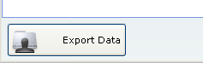

Pressing the button will select the currently highlighted record from the search list for export. A dialog will appear allowing the user to select what folder the data export should be created in. Once the location is specified, the export of the data will begin.

Requirement #4.36: The following data should be exported:

- The raw coefficients as well as the center point and angle of the images
- The raw report data (data that would display in the report)
- Calibration images
- Energized images
- Finger Images (if applicable)
- Calibration data (the number of pixels that failed validation)

Specification: In the folder selected by the user, the export process will create a root folder using the following naming convention:

{selected folfder}\{last Name}_{Treatment Date Time}

In that folder, the following folder structure is created:

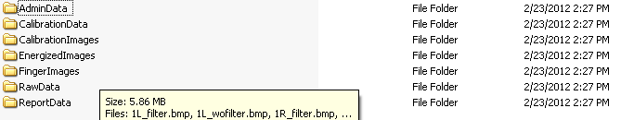

The above folder will contain the following:

AdminData: AdminScoreDump.csv – A CSV format file that will contain the Naive Bayes scores and a subset of the LR scoreing components. This was not called out in the requirements, but could be helpful to a researcher.
CalibrationData: A CSV file containing a line of data for each calibration image, specifying how many pixels failed validation in the image.
CalibrationImages: This folder will contain 10 .bmp format images that are the calibration images that were collected for the scan. The files will be named using the following convention:
{Finger Hand Marker}_Calibration_Image_#{image number}.bmp
EnergizedImages: This folder will contain 20 bmp format images that are the energized images captured for the exported scan. The images are named using the following convention:
{Finger Hand Marker}_(filter or wofilter).bmp
FingerImages: This folder will contain 20 bmp format images that are the finger images captured for the exported scan (if they exist). The images are named using the following convention:
{Finger Hand Marker}_(filter or wofilter).bmp
RawData: This folder contains a CSV format file containing the raw data collected from the images that describes the images. This would include values such as center point, angles, normalized area, form, etc.
ReportData: This is a CSV format file containing the values that are presented on the ClearView report.

Requirement #4.37: Calibration images must be saved with the raw data.

Specification: A link to the images is saved with each scan (raw data collection) that is done. The actual images are not duplicated for each scan, this is why a link to a single location where the images are stored is used.
Requirement #4.38: The final report data must be saved to the ClearView database.

Specification: The final report data is stored in a table in the ClearView database called “Severity”. The table is illustrated below:

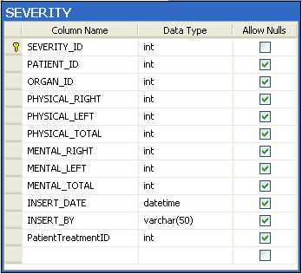

Requirement #4.39: The raw Logistic Regression and EPIC scores and ranks must be able to be exported.

Specification: The file AdminScoreDump.csv, contained in the AdminData folder of the export tree as discussed in the specification for Requirement #4.36, contains the EPIC and LR scores and ranks. A sample from the CSV file is shown below:

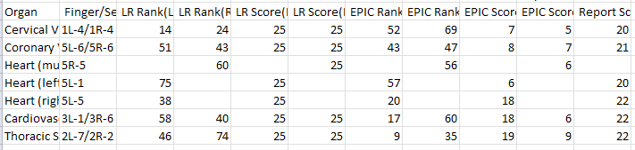

Requirement #4.40: An electronic record audit trail will be collected at the data collection points within the software. The audit trail will consist of who initiated the processing of the data (the current user ID) as well as the time and date stamp for the insertion of. The data collection points are:

- Patient Data Demographics (defined in the Patient Demographics Functions, Requirements document)
- Calibration images Patient images, raw data and results of the final algorithm
- A unique value will be created and used to delineate historical data that did not capture the name of the user ID that collected the data.

Specification: In the system, the demographic data is the only data mentioned in the requirement that can be edited over time. All other data mentioned cannot be changed once it is used in the system. To that end, an audit trail process has been developed for patient demographics, all data is audited with the following:

Who added/modified it.
What the data point was before and after.
What is the data point.
When it was changed/created.

An example of the data collected by the audit trail is shown below:

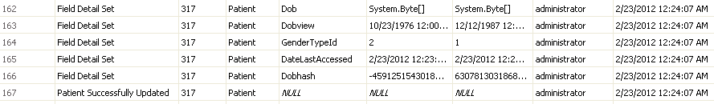

For the static data points (points that cannot be edited), the name of the user that collected the data as well as the date and time down to the second is collected and stored with the data.

In the situation where we do not know who collected the data (legacy data), we will default a username of “-Unknown-“.

Requirement #4.41: The user will have the ability to print a report of the Response Scale measurements.

Specification: The final reported Response Scale value is organized into a table listed by organ/structure with high level organ systems (i.e., Sensory and Skeletal Systems; Hepatic, Endocrine, and Nervous Systems; Cardiovascular System; Respiratory System; Gastrointestinal System and Renal and Reproductive Systems) that is ready to be printed.

This printable report is located in the Print Report tab displayed when the analysis is complete. The measurements are separated by Physical (images taken with a filter in place) and Autonomic (images taken without a filter in place) into columns that report the right and left hand results.

Additionally, measurements are reported with Normal values (measurements = 0 through 14) being displayed in a separate column than the Out of Range values (measurements between 15 and 25). Out of range values between 15 and 18 are displayed with a yellow background, values between 19 and 21 are displayed with an orange background and out of range values between 22 and 25 are displayed with a red background.

If an image results in a calculation that is unable to be performed (i.e., dividing by zero, etc.), the Response Scale value reported is -1 in red ink displayed in the Normal column.

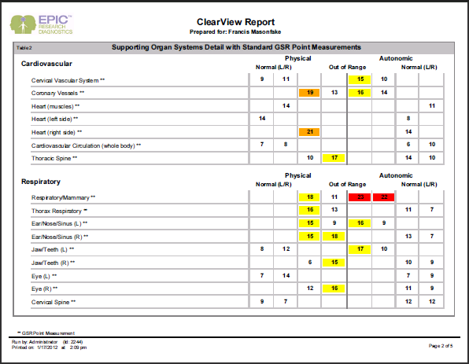

The first page of the report contains an overview of the findings based on the Niave Baise score as well as information about the scoring process.

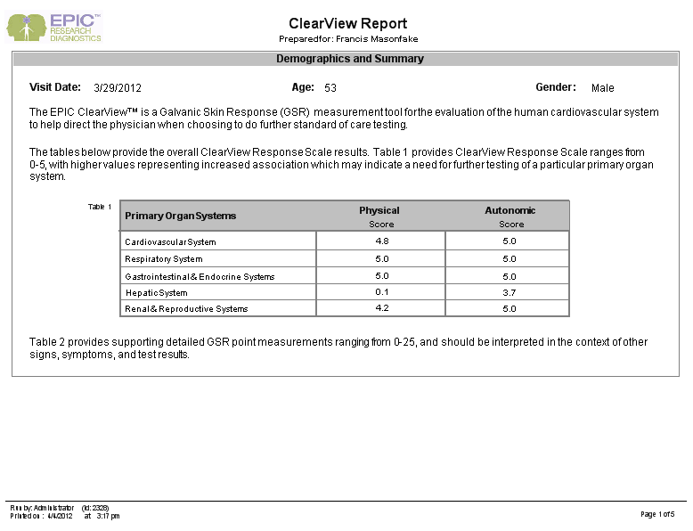

** Note: For any data processed prior to the implementation of this new report, table 1 above will always be zeros (0), as we do not recalculate the values when the report is displayed. In addition, the report raw data page (viewable by the administrator and techadministrator only) will be blank for data run on previous versions of the ClearView software.

Requirement #4.42: System should be able to graphically display the score results for organ systems, showing Physical and Autonomic scores and right and left values where appropriate.

Specification: The reporting page displays the score values for the organ systems in horizontal bar graph fashion. The graph created is overlaid on an image representing the severity through color gradients.

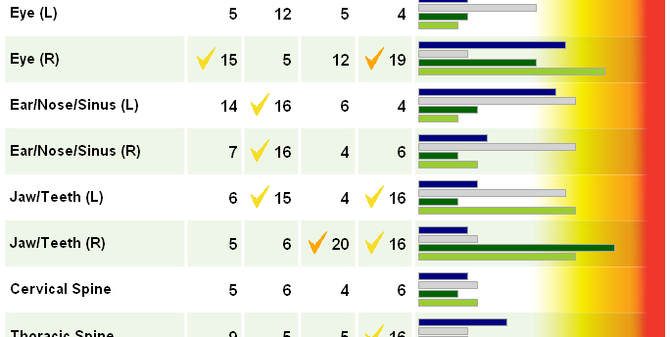

Requirement #4.43: The user will have the ability to view a graphical representation of the NS coefficient.

Specification: A subset of the NS coefficient calculations are displayed on a graph displayed in the NS Analysis tab when the analysis is complete. A graphical representation (representing a male physiology for male patients and female physiology for female patients) of the human body is displayed in the middle with the organ/structure label placed in an approximate correlated location to the organ/structure location on the body. A polar graph is used to approximate the z-score values for each organ/structure. The autonomic result is displayed in a different color than the physical result.

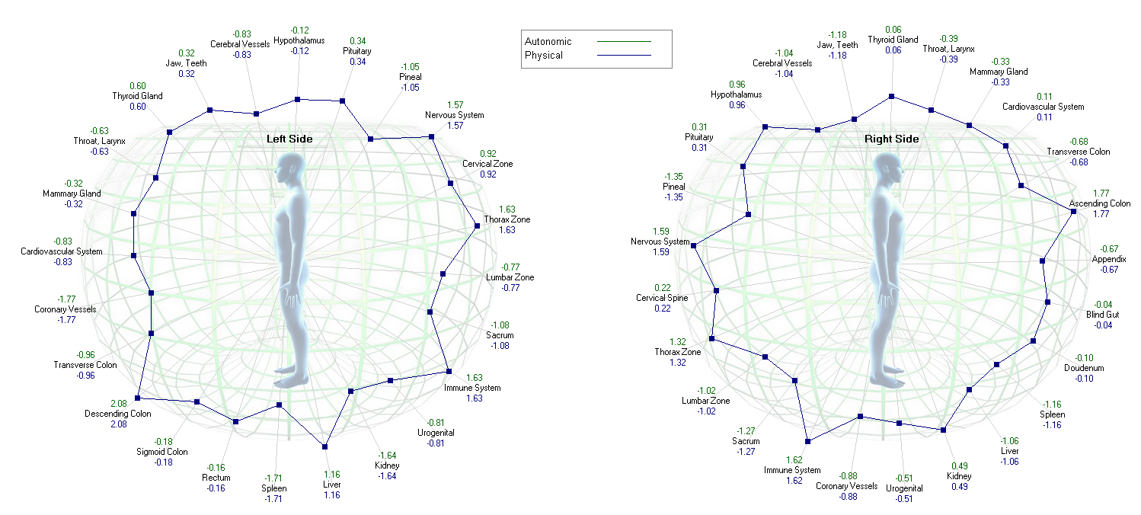

The table below contains a list of the values that are plotted on the chart, they are the same for both Autonomic and Physical.

Left Systems |  | Right Systems
Jaw & Teeth (Left Value) | 1L-5 | Jaw & Teeth (Right Value) | 1R-3
Cerebral Vessels | 3L-7 | Cerebral Vessels | 3R-7
Hypothalamus | 4L-1 | Hypothalamus | 4R-8
Pituitary | 4L-8 | Pituitary | 4R-1
Pineal | 4L-9 | Pineal | 4R-9
Nervous System | 4L-2 | Nervous System | 4R-7
Cervical Spine | 2L-8 | Cervical Spine | 2R-1
Thorax Zone | 2L-7 | Thorax Zone | 2R-2
Lumbar Zone | 2L-6 | Lumbar Zone | 2R-3
Sacrum | 2L-5 | Sacrum | 2R-4
Immune System | 3L-5 | Immune System | 3R-2
Coronary Vessels | 5L-6 | Coronary Vessels | 5R-6
Urogenital | 4L-4 | Urogenital | 4R-5
Kidney | 3L-2 | Kidney | 3R-5
Liver | 3L-3 | Liver | 3R-4
Spleen | 4L-3 | Spleen | 4R-6
Rectum | 2L-3 | Doudenum | 5R-1
Sigmoid Colon | 2L-2 | Blind Gut | 2R-6
Descending Colon | 2L-1 | Appendix | 2R-7
Traverse Colon | 2L-9 | Ascending Colon | 2R-8
Rt. Side Heart | 5L-5 | Traverse Colon | 2R-9
Cardio System | 3L-1 | Cardio System | 3R-6
Mammary Glad | 5L-3 | Mammary Glad | 5R-3
Throat, Larynx | 1L-4 | Throat, Larynx | 1R-4
Thyroid Gland | 4L-7 | Thyroid Gland | 4R-2

Requirement #4.44: The user will have the ability to view the energized image sectors in relation to a visual representation of the body known as the Biofield.

Specification: The energized image sectors are stretched and placed on image that represents the approximate location of the organ system and the image sector is specifically located to the organ/structure being reported. These images are referred to as Biofield images. These images are modified for each different body organ system. As the mouse travels over the displayed energized image sector, the Response Scale measurement designated by physical and autonomic and left and right had are displayed. The EPIC administrators also have access to a view of the entire energized finger image displayed to the left of the biofield images. These complete energized images will have two radii representing the edges of the finger sector being highlighted by the mouse over. Additionally, the entire energized image can be displayed in black and white or with color intensity that represents the differences in intensity present in the image.

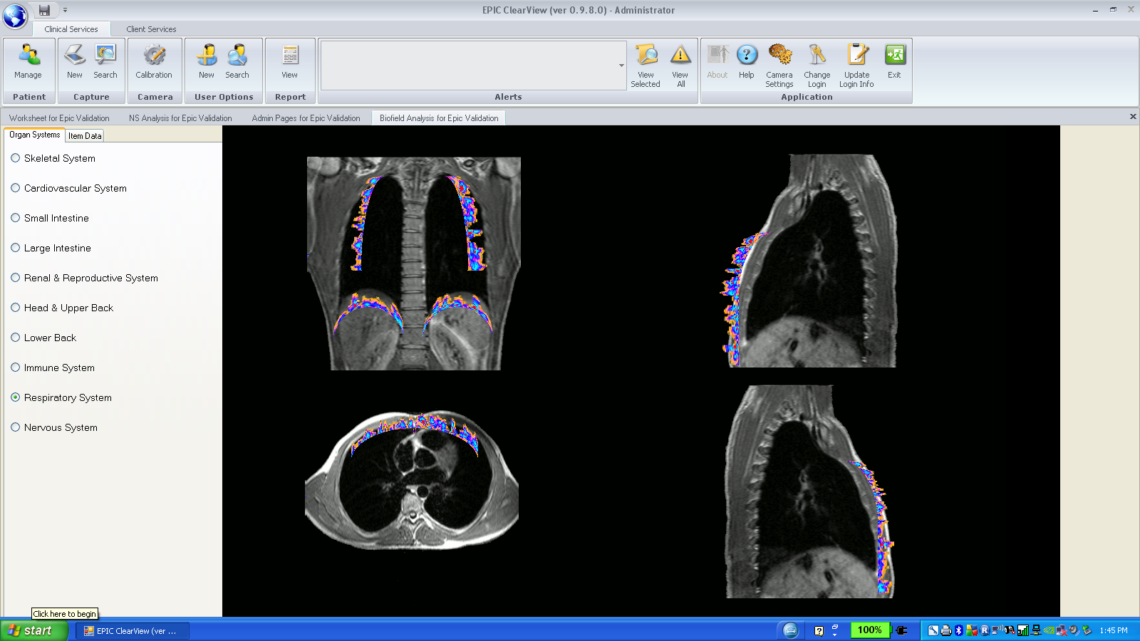

Requirement #4.45: The biofield page will be modified to remove the organ system tab. The radio buttons located on that tab will be moved to the main tab.
Specification: The radio buttons that appear on the organ system tab will be moved to the main tab as shown below:
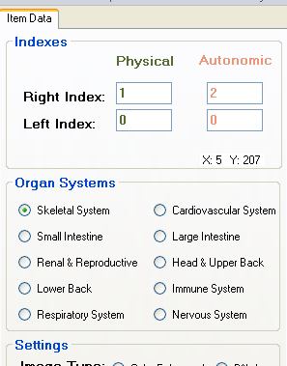
Requirement #4.46: The magnification algorithm used on the bio-field page will be modified to use a more smooth scaling routine.
Specification: Rather than using the existing third party to control the magnification image, use the built in features of .Net:
//high interpolation
g.InterpolationMode = InterpolationMode.HighQualityBicubic;
g.DrawImage(tempBmp, new Rectangle(0, 0, newBmp.Width, newBmp.Height), new Rectangle(0, 0, tempBmp.Width, tempBmp.Height), GraphicsUnit.Pixel);

Requirement #4.47: The Microsoft report viewer and reporting system should be replaced with the Crystal Reports reporting system with minimal change to the end user display.
Specification: Implement the Crystal report viewer for Visual Studio which can be downloaded from the Crystal Reports site royalty free.
Requirement #4.48: The ClearView report will be modified to have these areas in the "Full" license mode:
- The patient’s treatment date, age at time of scan and gender
- An overview section containing the indications for use, NB scores for all five organ systems
- The supporting organ system GSR readings
- A definitions section containing text definitions
Note: The word Normal should not be used in the report

Specification:
The initial section of the report contains the basic demographic information for the patient as well as an overview section where the Naive Bayes score is displayed.
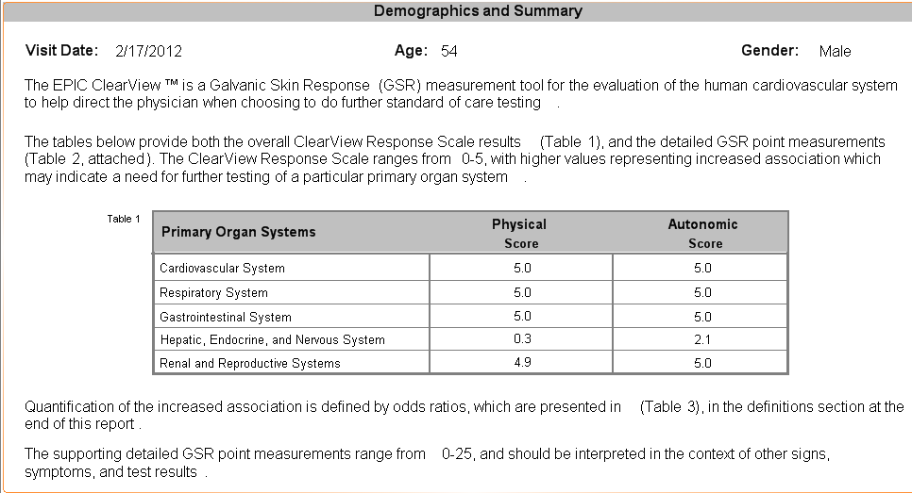
The detail section will contain the organ systems GSR readings.
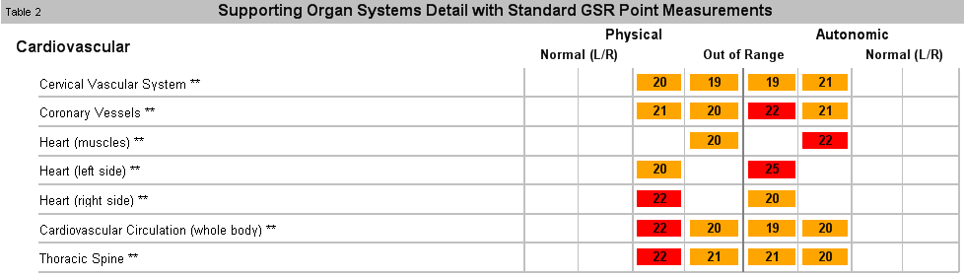
The definitions section appears on the last page.
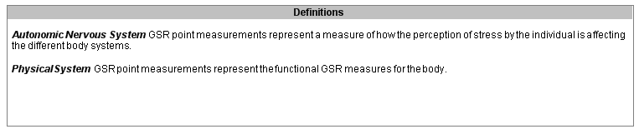

Requirement #4.49: The ClearView report will be modified to have these areas in the "Full" license mode:
- The patient’s treatment date, age at time of scan and gender
- An overview section containing the indications for use, NB scores for all five organ systems
- The supporting organ system GSR readings
- A definitions section containing text definitions
Note: The word Normal should not be used in the report

Specification:
The initial section of the report contains the basic demographic information for the patient as well as an overview section where the Naive Bayes score is displayed.
The detail section will contain the organ systems GSR readings.
The definitions section and odds ratios appear on the last page.

Requirement #4.50: The ClearView report for the "Basic" licensed product will display only one section that contains Hand/Finger/Measurement # and the appropriate scores.
Specification: Report display will be implemented as shown in the image below:
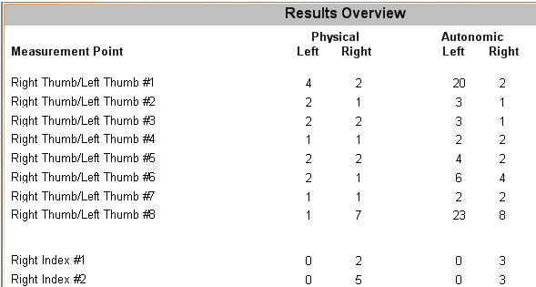

Requirement #4.51: The version of the firmware used in the device that was used to capture the patent images should be captured and stored with the treatment record.
Specification: The firmware version is queried when the scan process is started, it is then stored in the treatment record table.

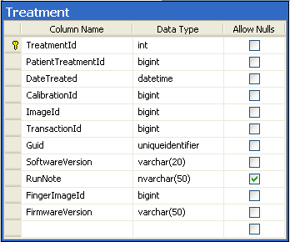

Requirement #4.52: The version of device firmware as well as the version of ClearView software should be displayed on the worksheet tab of the analysis output.
Specification: The worksheet tab has been modified to show the firmware and software version that was used to capture and analyze the data.

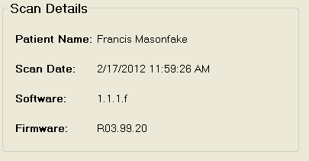

Requirement #4.53: The Id of the user that performed a calibration must be captured as well as the time and date of the calibration.
Specification: The username of the logged in user is captured and stored in the calibration table each time a new calibration process is run.
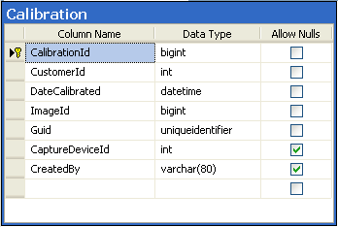

- Reference Documents

SS-204, Camera Functions- Specifications
SS-203-01, ClearView Finger Sector Map

Document Revision History
Version Number: | Description of Change: | Date: | Updated by:
000 | Introduction | 5/24/11 | A. Mason
001 | Modify algorithm to match development algorithm to include new coefficients, Naïve Bayes calculation, and Logistic Regression numbers which ultimately result in a revised EPIC scoring system.  Modify the Report layout to include paragraphs explaining the new algorithm outputs.  Modify color coding system for Out of Range values reported.  Modify method for exporting data (only for EPIC Administrator users) data to ensure all data is exported (including the raw data, raw report data, calibration images, calibration data, energized images, and lit finger images).  Audit trail established to ensure that the database stores the user ID, date and time of all raw data, raw report data, calibration images, energized images and lit finger image captures.  Biofields analysis tab now utilizes radio buttons rather than the leading tab to select the Organ Systems displayed.  The magnification algorithm has been modified to use a more smooth scaling routine.  The report view was modified from the Microsoft report viewer to use a Crystal Reports reporting system.  The device firmware version is stored in the database and displayed in the Worksheet tab.  Added the ability to export data relative to a scan including images, calculated values and report data.  Changed the ordering of the organ systems on the final report, the order is determined by the license type being used. | 3/5/12 | A. Mason
002 | Updated the report specification images to reflect the removal of the references to the words ‘odds ratios’. | 5/16/12 | A. Mason
003 | Updated the display requirements for the end user display | 7/18/12 | A. Mason

